CSS Profile Correction

I have made a mistake when filling in the “Student Non-filer” section of the CSS Profile. My College Board Financial Aid ID is EAA3S7F.

I entered AR$ 7720 in the “Income earned from work” item when I should have entered AR$ 0. The AR$ 7720 amount belongs to the “Untaxed income not provided elsewhere on this application” item.

# Original

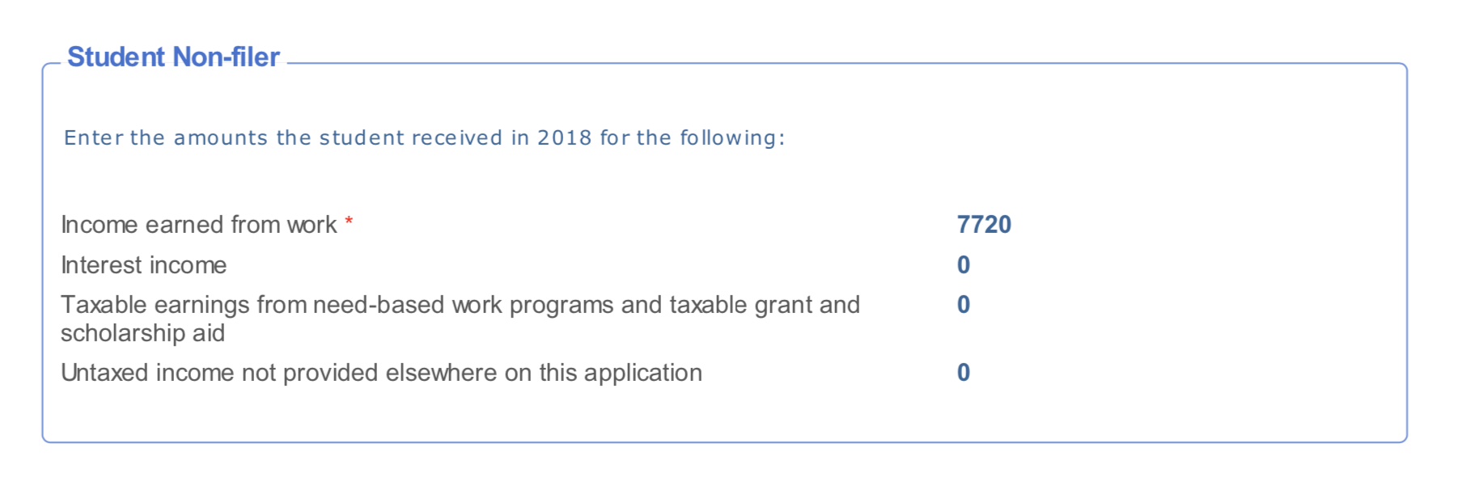

# Corrected

